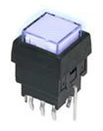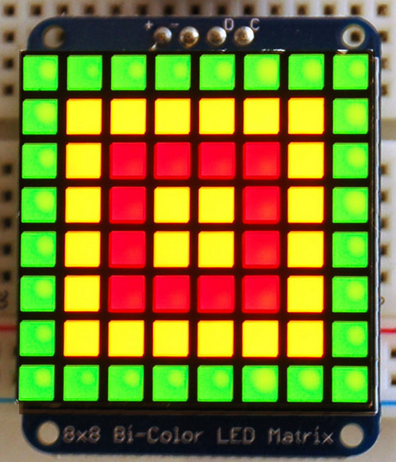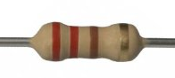

10K

220

3.3V

 3.3V

**Pi**

**Prop**

13

 P5

11

P4

7

 P2

GND

Vss

3

 P1

5

 P0

**Pi**

**Prop**



3.3V

 3.3V

GND

Vss

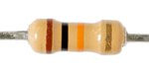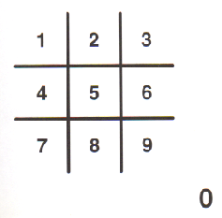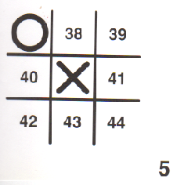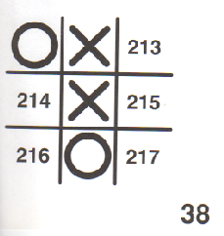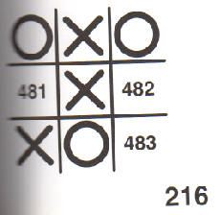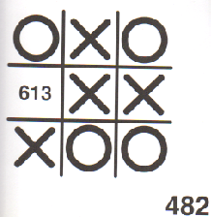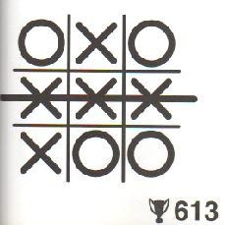

**SPLASH**

setButtonColor(2)

drawImage(TIC_T)

Tsplash

**Tic_TI**

drawImage(TIC_TI)

Tsplash

**Tic_TIC**

drawImage(TIC_TIC)

Tword

**WipeH_2**

andNotImageBuffer(H0)

orImageBuffer(H1,3)

Twipe

DN

WipeH_3 … WipeH_8

**WipeH_HOLD**

drawImage(SOLID_0)

Twipe

**PICKS**

Thold

DN

**PICKS**

DN

**PICKS**

DN

**PICKS**

DN

**PICKS**

**Tac_T**

drawImage(TAC_T)

Tsplash

**Tac_TA**

drawImage(TAC_TA)

Tsplash

**Tac_TAC**

drawImage(TAC_TAC)

Tword

**WipeV_2**

andNotImageBuffer(V0)

orImageBuffer(V1,3)

Twipe

DN

WipeV_3 … WipeV_8

**WipeV_HOLD**

drawImage(SOLID_0)

Twipe

**PICKS**

Thold

DN

**PICKS**

DN

**PICKS**

DN

**PICKS**

DN

**PICKS**

**Toe_T**

drawImage(TOE_T)

Tsplash

**Toe_TO**

drawImage(TOE_TO)

Tsplash

**Toe_TOE**

drawImage(TOE_TOE)

Tword

**WipeV_2**

andNotImageBuffer(B0)

orImageBuffer(B1,3)

Twipe

DN

WipeB_2 … WipeB_7

**WipeB_HOLD**

drawImage(SOLID_0)

Twipe

**PICKS**

Thold

DN

**PICKS**

DN

**PICKS**

DN

**PICKS**

DN

**PICKS**

**WipeH_1**

orImageBuffer(H0)

Twipe

DN

**PICKS**

**Wipe_V1**

orImageBuffer(V0)

Twipe

DN

**PICKS**

**Wipe_V1**

orImageBuffer(B0)

Twipe

DN

**PICKS**

**PICKS**

setButtonColor(0)

newGame()

pickCPU()

Tcpuon

**Opp_RANDOM**

drawImage(MR_RND)

**Opp_RANDOM2**

drawImage(SOLID_0)

**Opp_RANDOM3**

drawImage(MR_RND)

Tcpuoff

Tcpuhold

Tcpuon

**Opp_ONEDER**

drawImage(ONEDER)

**Opp_ONEDER2**

drawImage(SOLID_0)

**Opp_ONEDER3**

drawImage(ONEDER)

Tcpuoff

Tcpuhold

Tcpuon

**Opp_CAT**

drawImage(CAT)

**Opp_CAT2**

drawImage(SOLID_0)

**Opp_CAT3**

drawImage(CAT)

Tcpuoff

Tcpuhold

Twipe

**PickWipe_1**

orImageBuffer(B0,3)

**PickWipe_2**

andNotImageBuffer(B0)

orImageBuffer(B1,3)

Twipe

**PickWipe_3**

andNotImageBuffer(B1)

orImageBuffer(B2,3)

Twipe

**PickWipe_4**

andNotImageBuffer(B2)

orImageBuffer(B3,3)

Twipe

**PickWipe_5**

andNotImageBuffer(B3)

orImageBuffer(B4,3)

random

oneder

cat

**Pick2**

pickFirstPlayer()

human

cpu

**PLAY_HUMAN**

**PLAY_CPU**

Thold

**PLAY_HUMAN**

setButtonColor(2)

advanceCursor()

**InputA**

setCellAtCursor(3)

drawBoard()

*

TinputDN

DN

**InputB**

setCellAtCursor(0)

drawBoard()

**InputC**

setCellAtCursor(3)

drawBoard()

**HMove**

setCellAtCursor(2)

drawBoard()

getGameState()

TinputDN

TinputHELD

UP

cpu

tie

human

play

**OVER_HUMAN**

**OVER_TIE**

**OVER_CPU**

**PLAY_CPU**

setButtonColor(1)

getCPUMove()

setCellAtCursor(1)

drawBoard()

**OppC1**

setCellAtCursor(0)

drawBoard()

Tcpumon

Tcpumoff

Tcpumon

**OppC2**

setCellAtCursor(1)

drawBoard()

**OppC3**

setCellAtCursor(0)

drawBoard()

**MoveCPU**

setCellAtCursor(1)

drawBoard()

getGameState()

Tcpumoff

play

tie

**OVER_TIE**

human

**OVER_HUMAN**

cpu

DN

**OVER_HUMAN**

setButtonColor(2)

drawBoard()

**OVER_HUMAN2**

setButtonColor(0)

drawImage(SOLID_0)

Twinon

Twinoff

DN

DN

**OVER_CPU**

setButtonColor(1)

drawBoard()

**OVER_CPU2**

setButtonColor(0)

drawImage(SOLID_0)

Twinon

Twinoff

DN

DN

**OVER_TIE**

setButtonColor(3)

drawBoard()

**OVER_TIE2**

setButtonColor(0)

drawImage(SOLID_0)

Twinon

Twinoff

DN

DN

**OverWipe_1**

setButtonColor(0)

orImageBuffer(D0,3)

Twipe

**OverWipe_2**

andNotImageBuffer(D0)

orImageBuffer(D1,3)

Twipe

**OverWipe_HOLD**

drawImage(SOLID_0)

Thold

OverWipe_3 … OverWipe_15

**SPLASH**

Twipe